Life Insurance

There are many ways you can use a
life insurance policy to fund a gift
to American Baptist outreach.

You can name a particular ministry or
mission effort to receive a portion or all
of the proceeds of an insurance policy
no longer needed for family protection.

Another way is to take out a new policy,
naming the Kansas Baptist Convention For further information,
Foundation as a beneficiary or please contact
co-beneficiary, and then specifying in a
letter to the Foundation the ministry and
mission efforts you wish to support. Rev. Timothy Schwartz
Director of Planned Giving
Retirement Plans Cell: 913-424-9939
e-mail: timmans39@gmail.com
Income from retirement savings –IRA,
Keogh, 401(k), 403(b) etc – allows you 2921 Minnesota
to make new choices for yourself and Kansas City, KS 66102
your family.

However, understanding the consequences
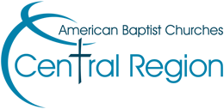
of these funds and choosing the right assets
to meet your security needs – while meeting
your giving goals – can be confusing.

In most cases, using retirement funds left
at your death to benefit Christian work,
while passing other assets to loved ones,
lessens taxes and increases benefits to all.
