2022 GIRL’S Praise Weekend
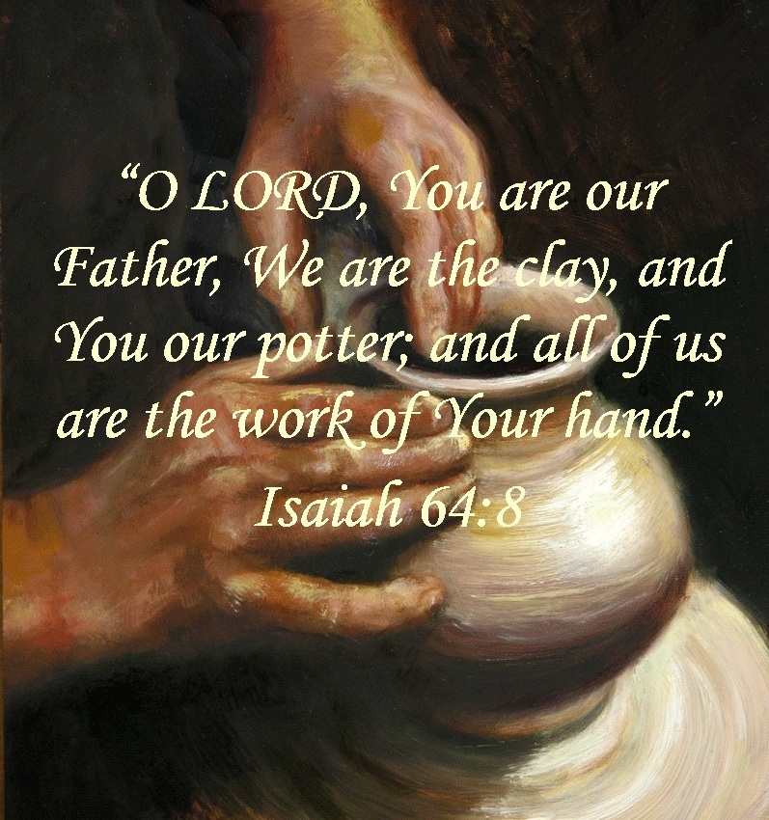
Early Bird Discount
Return your registration by May 31 and receive a $10.00 discount!

Camp Webster @ Salina, Ks
July 15 – 17, 2022
Girl’s Form

Please Print Legibly
Name:__________________________________________________

Age:__________________________ Birth Date:_______________________________

Street Address:________________________________________________________________

City:__________________________ State:____________________________________

Zip:___________________________ Phone:___________________________________

Email Address:________________________________________________________________

Church Name: ________________________________________________________________

Church City: ________________________ Church Phone Number: _____________________

AB GIRLS Group (check one) T-Shirt Size (check one)
_____ Girls of Joy (3rd - 5th Grade) YM ___ YL ___
_____ Girls of Faith (6th - 8th Grade) AS ___ AM ___
_____ Young Women of Hope (9th - 12th Grade) AL ___ AXL___

Return Registration with $95.00 payment. Registrations postmarked on or before May 31, 2022 receive a $10.00 Discount and may remit $85.00.

Send registration form and check made payable to AB GIRLS Central Region to: Rebecca Pushee
3835 Milton Circle
St George, KS 66525-9512
Questions: Contact Rebecca Pushee at 785 458-2520 or rebeccapushee@usd475.org

**Sponsored by the AB GIRLS of the Central Region
A Ministry of the American Baptist Women of the Central Region

