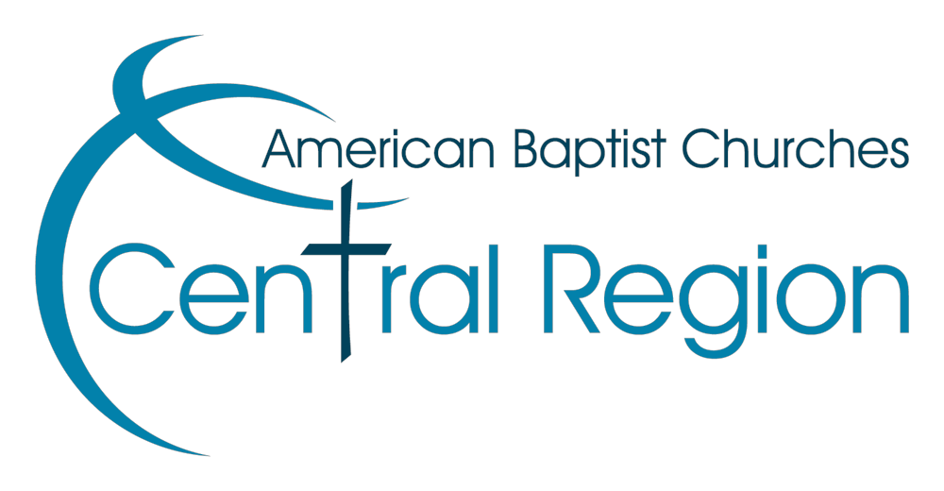
ABCCR Special Ministry Grant Application Due at Region Office April 15, 2024 Please submit to Gregg Hemmen
(gregg.hemmen@abccr.org) or Jennifer Schneider (jennifer.schneider@abccr.org)

Church/Institution:
Complete Address:
Name of Contact:
Phone Number of Contact:
Email Address of Contact:
Project/Proposal Administrator:

In the space below (feel free to use additional pages to adequately describe your project), please provide thorough explanations for the following:
- Explanation of the project or ministry
- Amount of money requested
- Total anticipated cost of your special ministry
- Target group for this special ministry
- How the church will report ministry effectiveness and use of grant monies
- Church investment in the ministry (can include time, facilities, money, etc.)
- Is this a continuation of a previously funded ministry through Special Ministry Grants?

