


Application Period
Special Ministry Grants
Do You Have an Idea to Reach
Your Community, But Lack the Money??
Let Us Help.....



All grant proposals must be received in the Region Office no later than April 15, 2026. Successful grant applicants will be notified after the ABCCR Board of Directors meet in May. Remember, all grants shall be determined on a competitive basis according to the guidelines enclosed.

Grant money will be awarded once a year.

For more information,
contact the Region Office 785-272-7622
jennifer.schneider@abccr.org or
gregg.hemmen@abccr.org

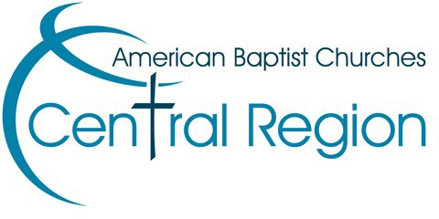

American Baptist Churches of the Central Region

5889 SW 29th Street
Topeka KS 66614-5505
Phone: 785-272-7622

Jennifer.schneider@abccr.org or
gregg.hemmen@abccr.org

AMERICAN BAPTIST CHURCHES
OF THE CENTRAL REGION

SPECIAL MINISTRY GRANT GUIDELINES

SPECIAL MINISTRY GRANTS ARE DESIGNED TO PROVIDE FINANCIAL SUPPORT TO ENABLE EFFECTIVE MINISTRY PROGRAMS BY
CONGREGATIONS AND ABCCR RELATED INSTITUTIONS IN THEIR COMMUNITIES.

CRITERIA
Proposals for Special Ministry Grants are to be submitted in writing to the Region Office during the application window of February 15 - April 15. Grants will be awarded on a competitive basis. Grants will not exceed $5,000. The total grants awarded, including Pastoral Salary Support Grants, cannot exceed 4% of the principal balance of the Church Transformation Fund.
Proposals will be judged on the following criteria:
  - Appropriateness for the Ministry setting
  - Creativity and vision for
effective ministry
  - Financial need
  - Ministry effectiveness and intended use of grant monies
  - Church investment in the ministry (could include time, facilities and/or money)
  - Project or proposal administrator

PROPOSAL
Grant proposals need to include the following information:
  - Name and contact information of church/institution.
  - Explanation of project or ministry
  - Target group for this special ministry
  - Total amount requested
  - How the church will report ministry effectiveness and use of grant monies
  - Church investment in the ministry (could include time, facilities and/or money)
  - Project or proposal administrator (See Proposal Application Form)
  - Digital submissions must be merged into single PDF

REVIEW & AWARD
Proposals will be reviewed by the Administration & Finance Vision Team, who will recommend awards to the ABCCR Board of Directors at its May Board meeting. Proposals will be judged in connection with Pastoral Salary Support Applications on a competitive basis as set forth in the Criteria. Notification of awards will be sent within two weeks following the board meeting, including amount of the grant award and any special requirements attached to the grant. An effort will be made to contact all applicants regarding their proposal.

APPLICATION WINDOW
Applications will be received at the Region Office between the dates of February 15 and April 15 only. There is only one
window of application for each year.

ELIGIBILITY
Ministries that have received a grant are eligible to re-apply in successive years; however, repeat grants will not be given special consideration.

FULFILLMENT
Ministries that receive a grant must document usage of the grant monies and submit a report to the Region Office by the end of the calendar year in which the grant is received.

Applications and Reports can be submitted attention the Finance Office or emailed to gregg.hemmen@abccr.org or jennifer.schneider@abccr.org

If mailing, send to: ABCCR
5889 SW 29th Street
Topeka KS 66614-6605

